OBELEAGU ODINAKACHUKWU EMMANUEL

CLASS: LUMINARIES (COHORT 11)

1. What is Normalization?

Ans: Normalization is a technique used in reducing and eliminating data repeatation. It divides larger tables into smaller tables.

2. When is a table in INF?

Ans: A table is in 1NF if and only all columns contain only atomic value. i.e, each column can have only one value for each row in the table.

3. When is a table in 2NF?

Ans:This means only if a relation is in 1NF and meet the requirements or rules and every non key attributes is fully dependent on primary key.

4. When is a table in 3NF?

Ans: This is achieved when: table is in second normal form(2NF).

5. An agency called Instant Cover supplies parttime/temporary staff to hotels in Scotland. Figure 12.4 lists the time spent by agency staff working at various hotels. The national insurance number (NIN) is unique for every member of staff. Use the

diagram below to answer the question below

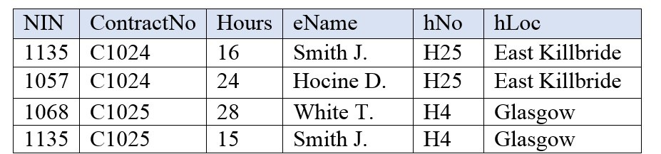

Normalize this table to third normal form. State any assumptions.

Ans:

A

|  |  |  |  |
| --- | --- | --- | --- |
| NIN | ContractNo | Hours | eName |

B

|  |  |  |
| --- | --- | --- |
| eName | hNo | hLoc |

6 To keep track of students and courses, a new college uses the table

structure in Figure 12.3.

Draw the dependency diagram for this table.

Ans:

|  |  |  |  |  |  |  |
| --- | --- | --- | --- | --- | --- | --- |
|  | StudentID | SudentName | CourseID | CourseName | Grade | CourseDate |
| Sample Value |  |  |  |  |  |  |
| Sample Value |  |  |  |  |  |  |
| Sample Value |  |  |  |  |  |  |

Student >> Course

Student >> Grade

7. Using the dependency diagram you just drew, show the tables (in their third normal form) you would create to fix the problems you encountered. Draw the dependency diagram for the fixed table.

A

|  |  |  |  |
| --- | --- | --- | --- |
| StudentID | StudentName | Grade | CourseID |

B

|  |  |  |
| --- | --- | --- |
| CourseID | CourseName | CourseDate |